 |  | St Ninian’s R.C. Primary School  Dochart Terrace  Dundee  DD2 4HB  Tel: 01382 435904
Director of Education, Children and Families Service  Mr P. Clancy | Head Teacher  Lisa MacPhail | E-mail: stniniansrcprimary@dundeeschools.scot
05/10/21
QUESTIONNAIRE RESULTS
Dear Parent/Carer,
A huge thank you for filling in our questionnaire last week via the link on Seesaw. We had 89 returns which was fantastic. The results are detailed below.

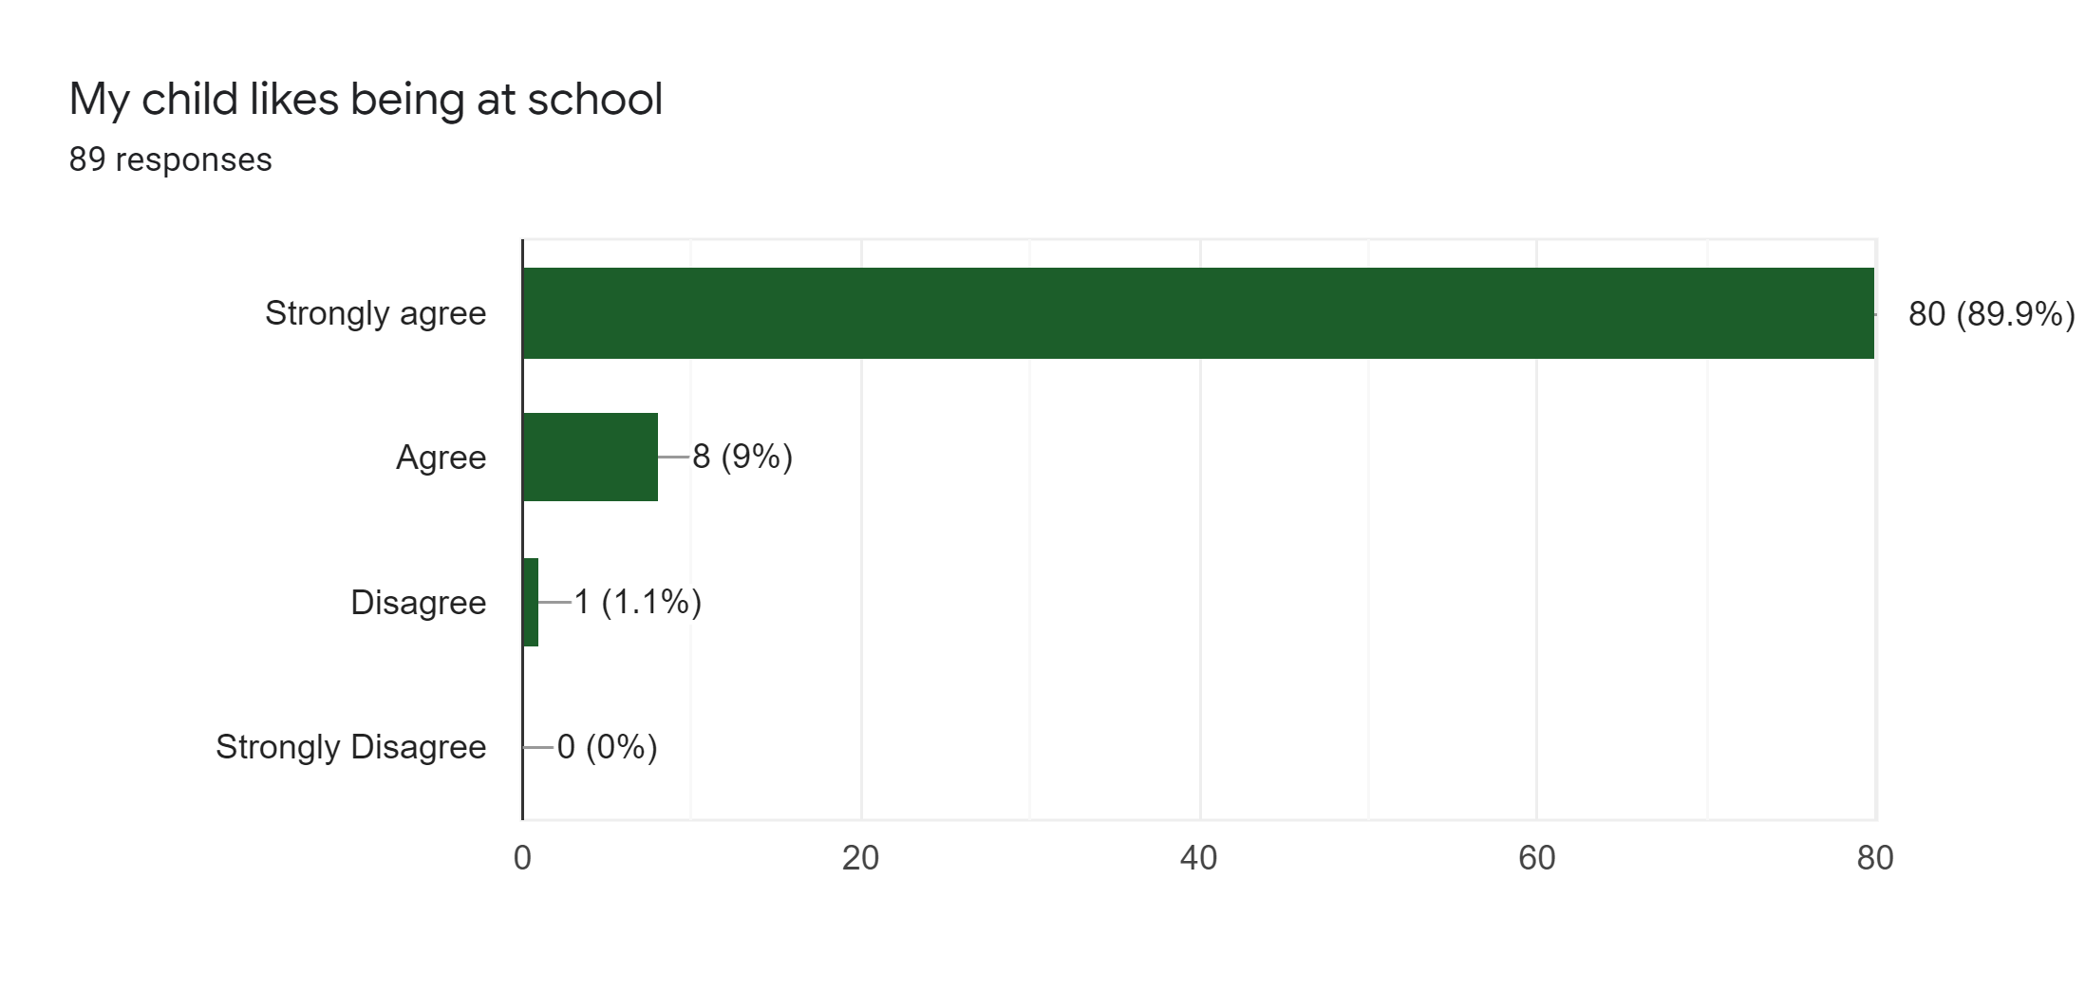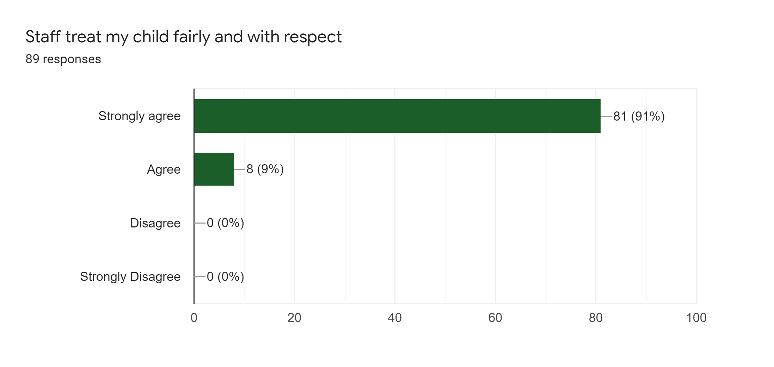

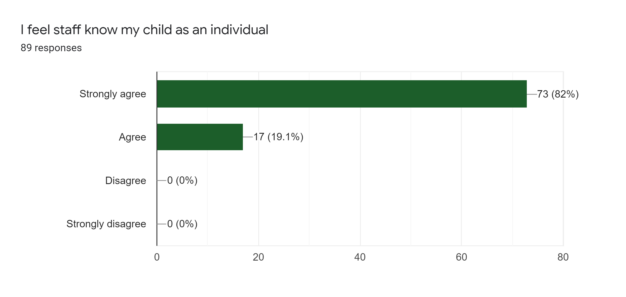

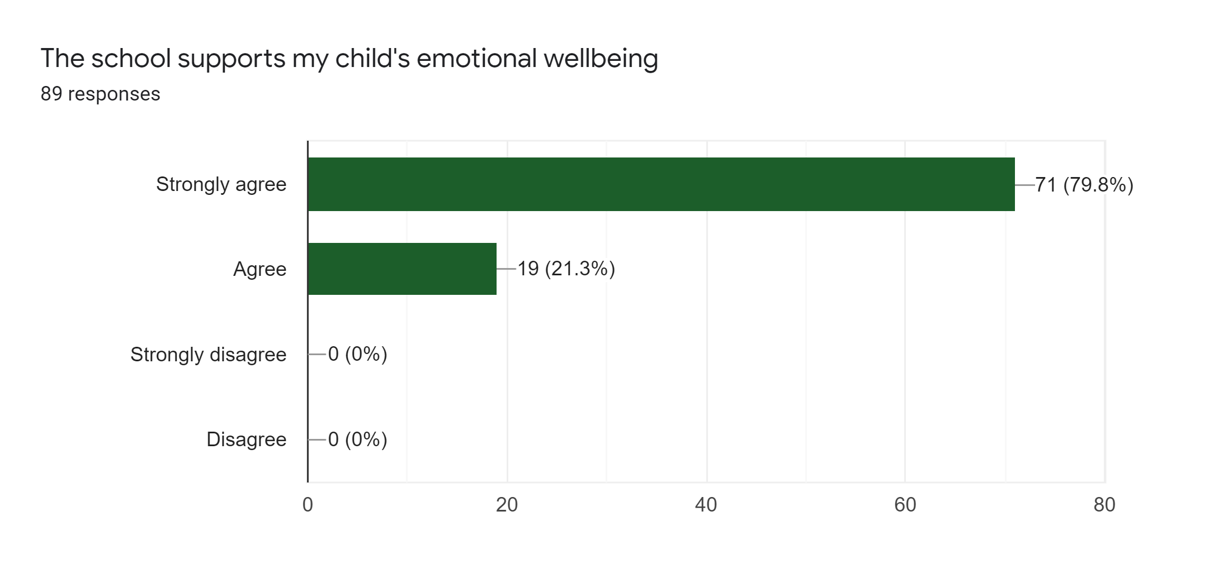

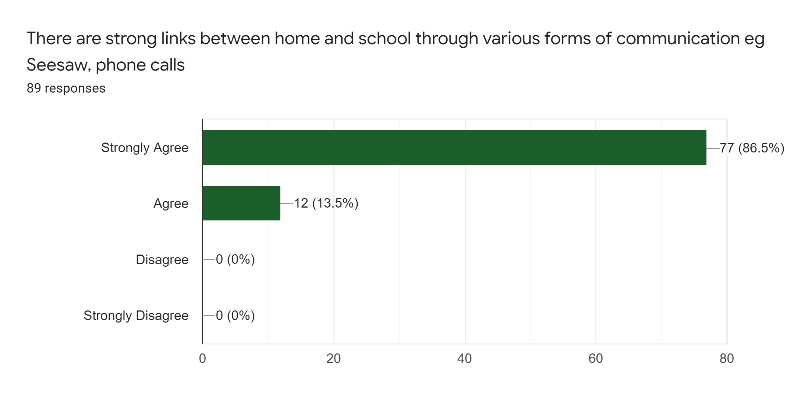

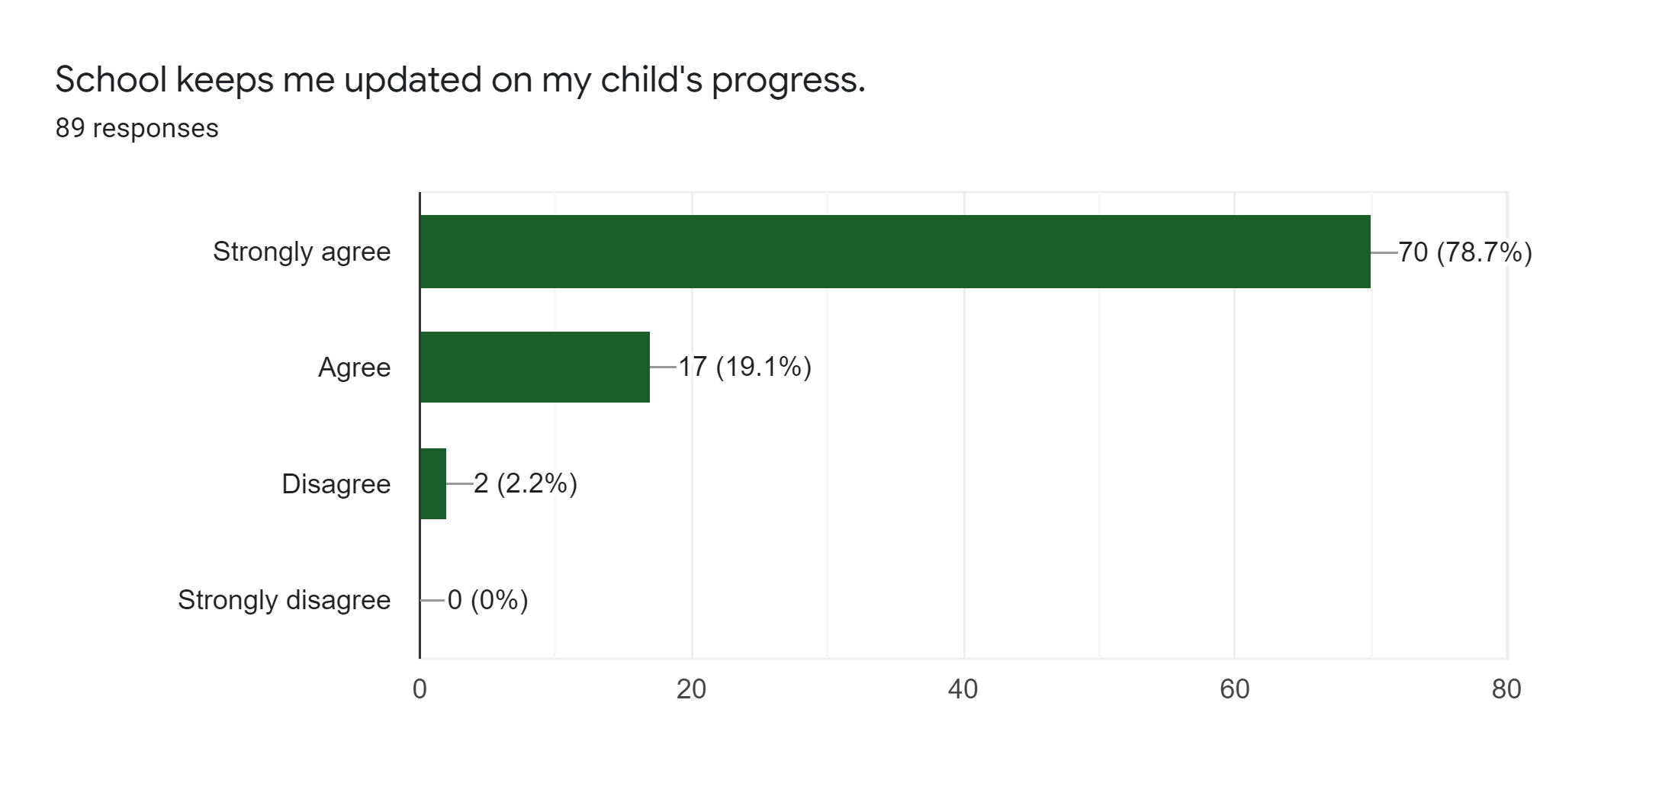

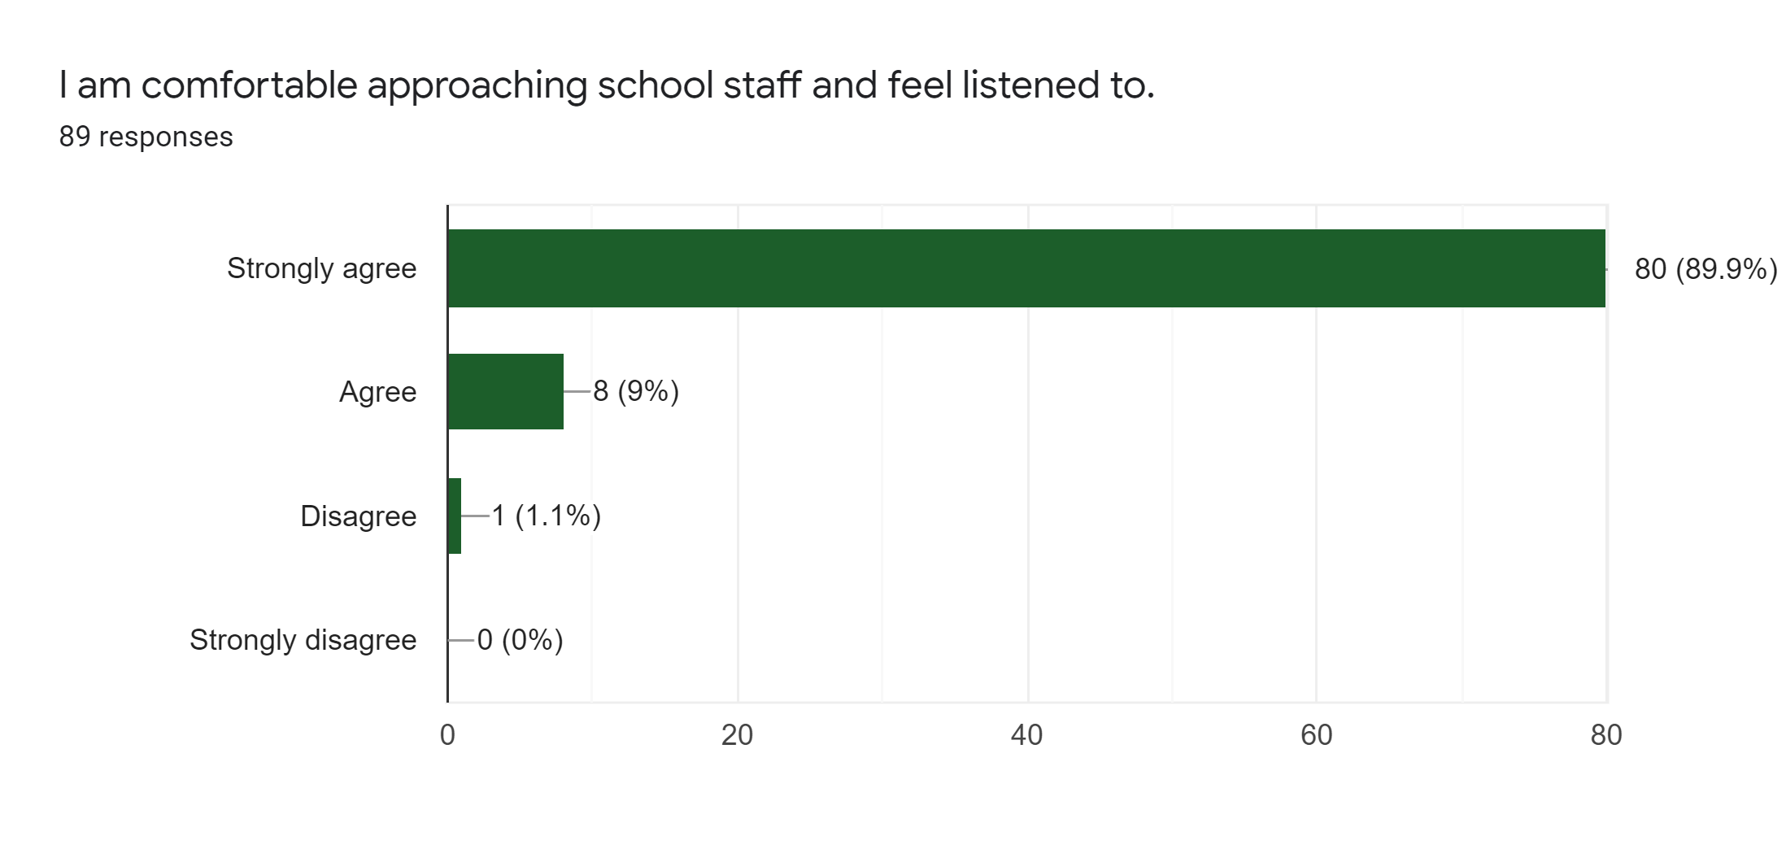

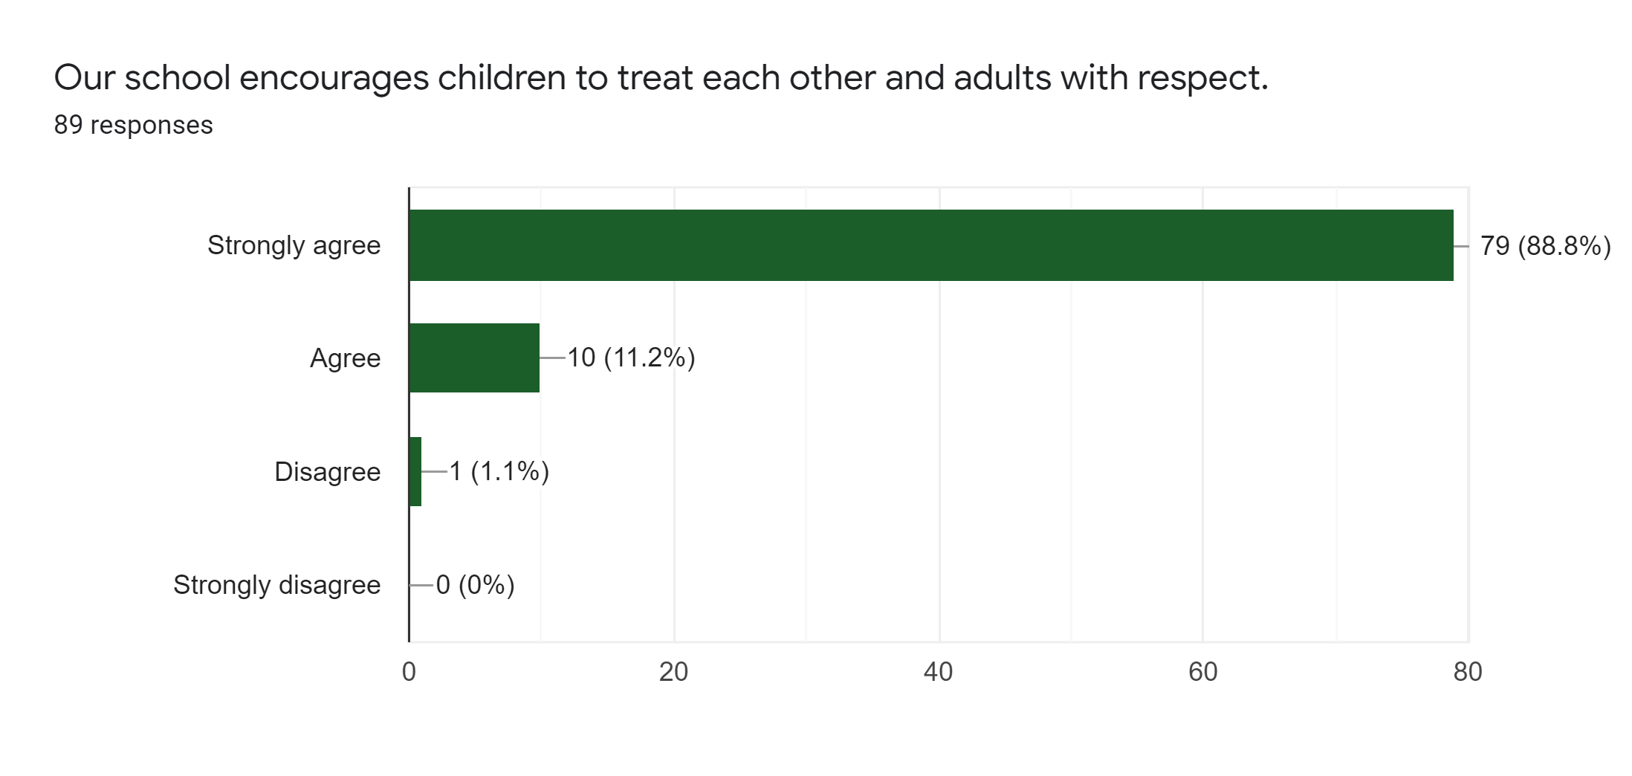

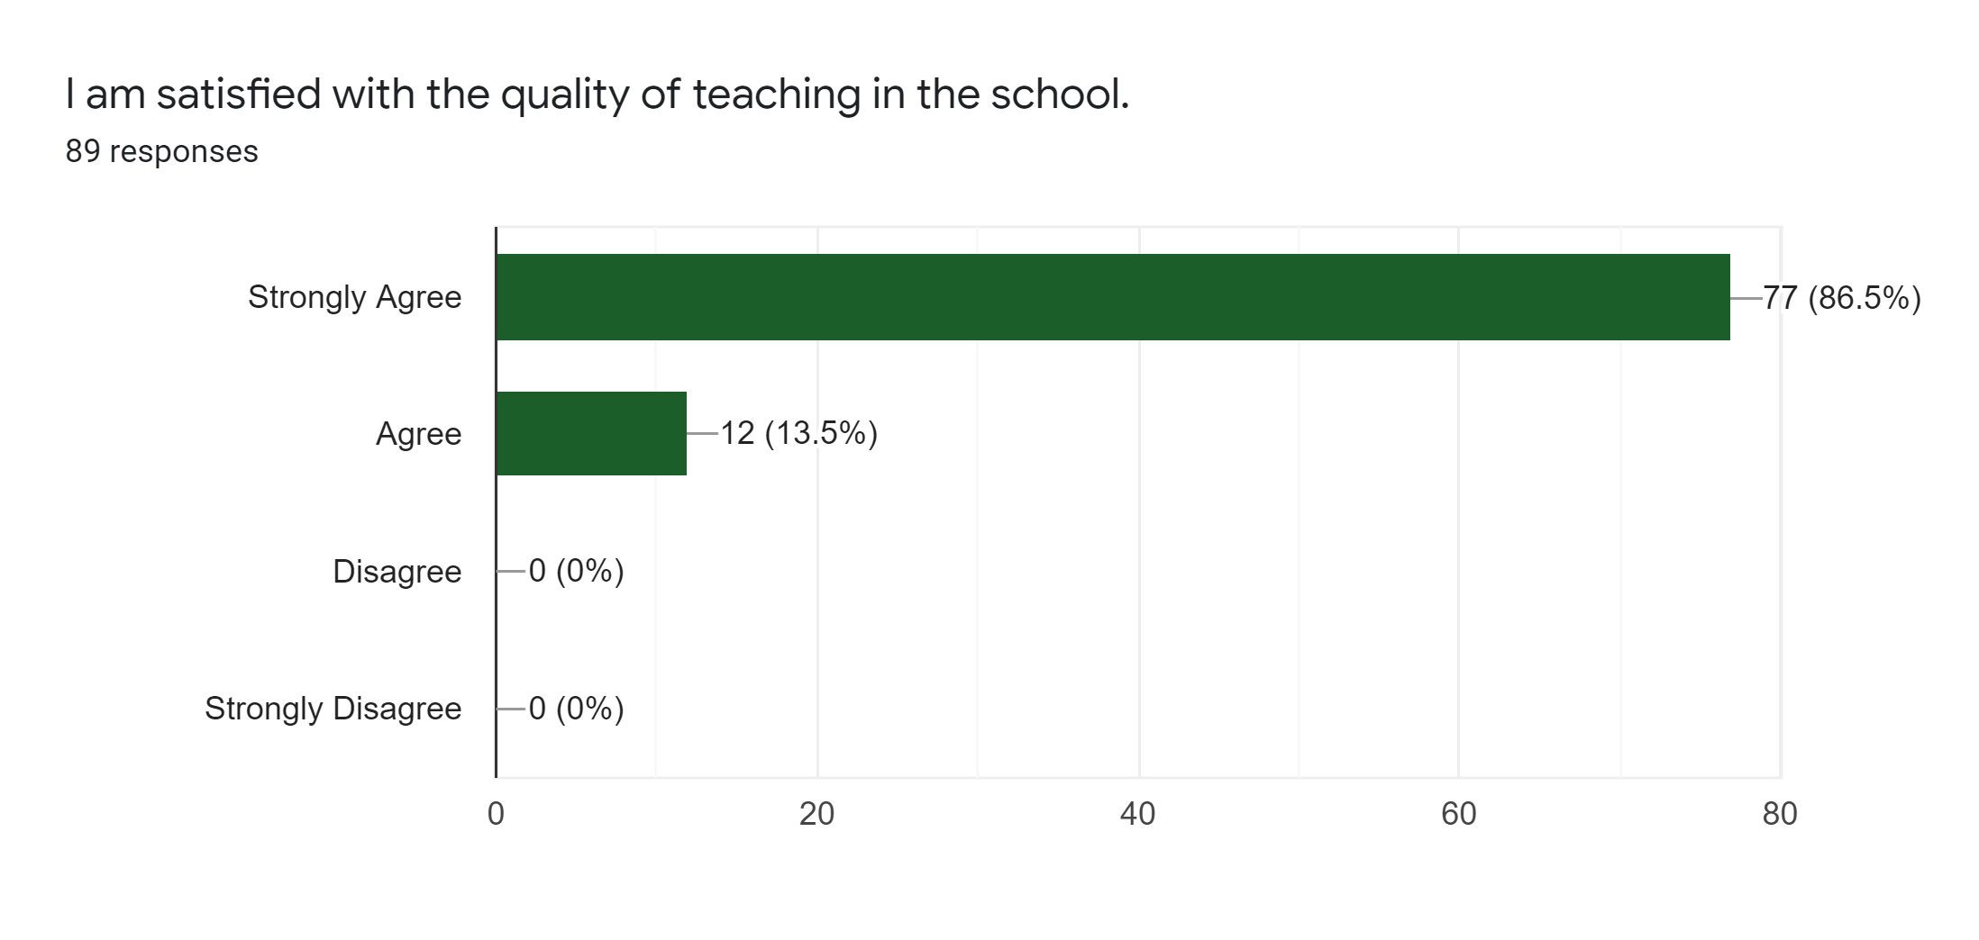
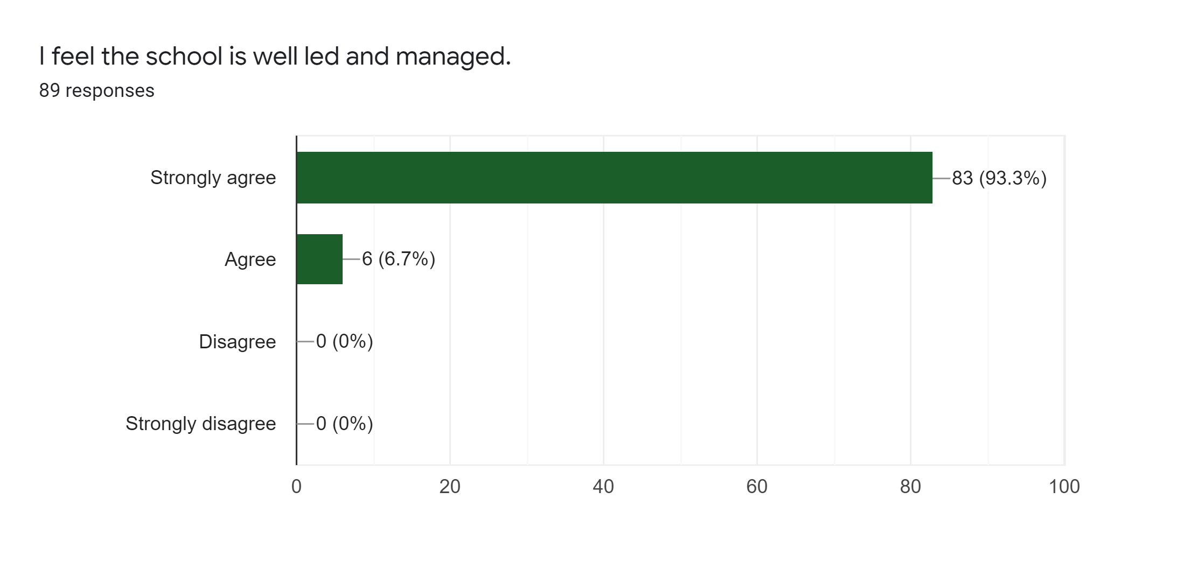
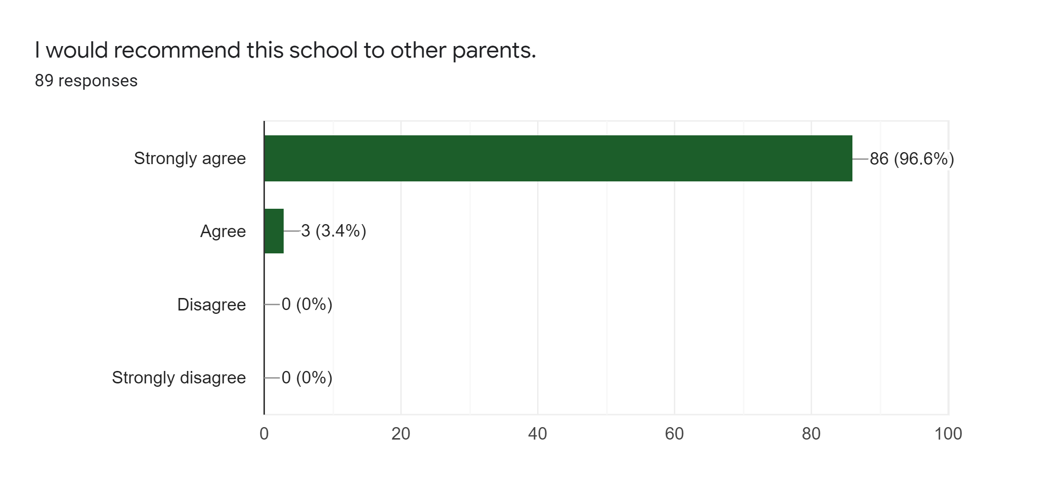
The comments shared were so positive and I want you to know how loved and valued all our team felt while reading them. It really warmed our hearts to hear how much you value all the hard work, effort and love my team put into their roles every day.

There were a couple of questions/comments that require further work, and we thank you for those and will ensure as a staff we move forward with them (e.g. homework across all classes)

Many thanks again

Lisa MacPhail
Head Teacher

