Vision: **To be the best we can be**

Values: **Love and Respect**

Aim: **To get it right for every child** by: Raising attainment in literacy & numeracy Improving health & wellbeing outcomes for all  Inspiring learning for life in a safe, inclusive & nurturing environment  promoting the Gospel values of love, kindness, patience, trust & respect in all that we do

**School Roll School attendance %ASN PEF TOTAL LOCAL COMPARATOR RRS AWARD**

**

**Victoria Park**

**£77,175**

**27.66**

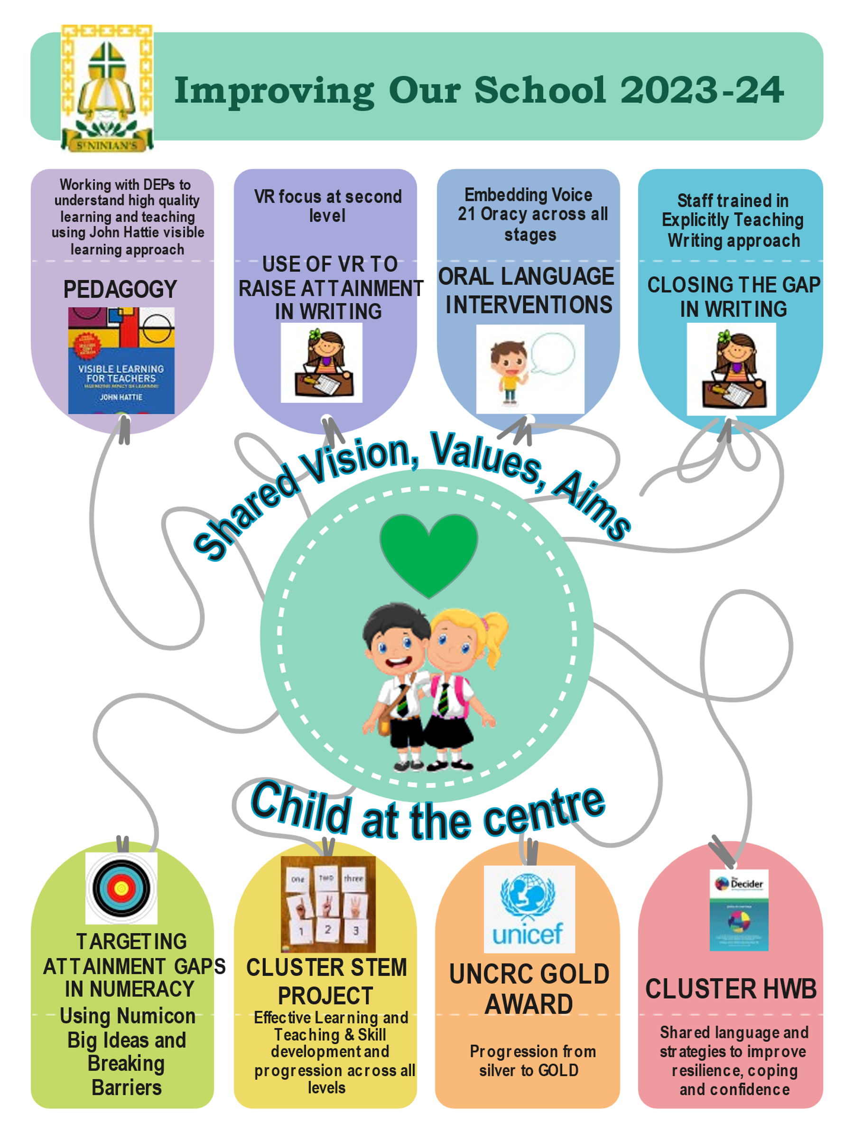

|  |  |  |  |  |
| --- | --- | --- | --- | --- |
| **SIP Priority 1** | ***Improving attainment in literacy*** | | | |
| **NIF DRIVER**    **SCHOOL IMPROVEMENT** | | **EDLM PRIORITY PROGRESS/PARTICIPATION** | **PEF (where applicable)**  ***Intervention for equity & cost*** **Promoting a high-quality learning experience**  **£20,000** |   **2.3 L, T &A**  **2.2 Curriculum** |
| **Improvement Target** | | **Supporting Evidence** | **Impact of intervention** | **Progress (Jan/March/June)** |
| ***Oral language Interventions***   * Voice 21 Oracy-embedding approach across all stages to improve listening and talking through curriculum design.   ***Closing the attainment gap in writing***   * Explicitly teaching strategies for writing approach consistently used across all levels.   *Modelled and shared Writing*  *Guided Writing*  *Independent Writing*   * Use VR to stimulate and support writing with second level being priority. | | Writing attainment has continued to dip, sitting at 80%. Although listening and talking attainment sits at 96%, we feel a focus on these skills will raise attainment and improve strategies in writing. | ***Progress***  AoL data for reading and writing above local and national comparator schools.  Increased engagement and attainment in writing, particularly at 2nd level-SNSA/CFE info.  ***Participation***  Increased pupil engagement in listening and talking. |  |

|  |  |  |  |  |
| --- | --- | --- | --- | --- |
| **SIP Priority 2** | ***Improving attainment in numeracy and mathematics*** | | | |
| **NIF DRIVER**    **SCHOOL IMPROVEMENT** | | **EDLM PRIORITY PROGRESS/PARTICIPATION** | **PEF (where applicable)**  ***Intervention for equity & cost*** **Targeted approaches to numeracy**  **£10,000** |   **2.3 L, T &A**  **2.4 Personalised support**  **2.2 Curriculum** |
| **Improvement Target** | | **Supporting Evidence** | **Impact of intervention** | **Progress (Jan/March/June)** |
| ***Targeted Numeracy Interventions***   * Explicitly teaching key concepts to targeted children at second level with gaps in learning using Numicon “Big Ideas” and “Breaking Barriers”   ***Cluster STEM project***   * Embed a framework across all stages to develop staff and pupil knowledge and expertise in science, technology, engineering, and mathematics. | | On current predictions, 25% (22 pupils) of next year’s P5-P7 are not expected to achieve expected national standards by the end of P7.  Staff/Pupil feedback is clear that STEM is inconsistently taught, staff lack skills and confidence to teach this, and a skills-based progression would support this to be embedded consistently across all levels. | ***Progress***  AoL data for numeracy above current predicted levels in June 2024  ***Participation***  Increased pupil engagement |  |
| **SIP Priority 3** | ***Improving outcomes in health and wellbeing*** | | | |
| **NIF DRIVER**    **SCHOOL IMPROVEMENT** | | **EDLM PRIORITY PRESENCE/PARTICIPATION** | **PEF (where applicable)**  ***Intervention for equity & cost*** **Professional learning and leadership**  **£5000** |   **3.1 Ensuring wellbeing, equality and Inclusion** |
| **Improvement Target** | | **Supporting Evidence** | **Impact of intervention** | **Progress (Jan/March/June)** |
| ***Rights Respecting Schools***   * Achieve our GOLD award, demonstrating the RRS approach is fully embedded in our school and shared with key partners.   ***Cluster Work***   * In partnership with our cluster partners, embed support for young carers and care experienced children. * Embed approach to building self-help skills to ensure positive mental health outcomes.   ***Pedagogy in practice***   * Partnership with DEPS -exploring pedagogy and research to support high quality learning and teaching | | We achieved our SILVER award at the end of session 21/22. In session 22/23, we have linked articles to SHANARRI and our Decider skills to ensure an approach that encompases all of these essential components.  There is inconsistency across the board of what high quality learning and teaching actually looks like. Using Hattie will support us to better understand what we are striving for and give us a research based approach for improvement. | ***Participation***  Increased pupil engagement  ***Presence***  Increased pupil engagement |  |

|  |  |  |  |  |  |  |  |
| --- | --- | --- | --- | --- | --- | --- | --- |
| **Further PEF Interventions (not included in SIP)**    **Identified Equity Gap Differentiated Support**  **Promoting healthy lifestyles**  **Early Intervention and Pre** | | | | | | | |
|  | | **EDLM PRIORITY Progress** | | **Differentiated Support**  **Diagram  Description automatically generated with low confidencePromoting healthy lifestyles**  **Early Intervention and Prevention** | |   **1.3 | 3.2** | |
| **Identified Equity Gap** | **Action** | | **Outcomes and Measurement** *Including use of HGIOS Challenge questions* | | **Responsibility | Resource cost** | | **Progress** |
| **Outdoor experiences**  **Software packages**  **IT Hardware**  **Resources to support learning across all curricular areas** | Paying for targeted pupils to attend Dalguise and school trips/cost of buses for learning trips  Education packages to support targeted interventions in literacy/numeracy/HWB  Hardware to support high quality learning and teaching.  (Interactive board/laptop/ipads)  High quality learning resources to support high quality learning and teaching | | All children being able to participate in these learning experiences.  All children having access to learning styles that suit their needs in order to attain expected levels.  All children having access to learning styles that suit their needs in order to attain expected levels.  All children having access to resources that suit their needs to attain expected levels | | **£5,000**  **£3000**  **£7,000**  **£5,000** | |  |

|  |  |  |
| --- | --- | --- |
| **Summary of PEF Spend** | | |
| **Area of spend** | **Details** | **Budgeted allocated** |
| **Support staff** | **Barbara additional support hours** | **£5,000** |
| **Supported study** | **Mark 10 hours/Sarah 10 hours per month** | **£10,000** |
| **Transport/Trips** | **Dalguise/class trips/holiday clubs** | **£5,000** |
| **CLPL** |  | **-** |
| **Resources** | **STEM resources**  **IT hardware and software**  **Numicon Big Ideas/Breaking Barriers**  **Learning Resources-cross curricular** | **£47,000** |
| **Payments to other bodies** | **Voice 21**  **Explicitly teaching writing** | **£2500**  **£2500** |
| **Other** | **Social and Emotional wellbeing**  **Promoting a high-quality learning experience** | **£5,000** |
| **Total** |  | **£72,000** |